目录

说明 2

1.1登陆 2

1.2注册 2

1.8修改密码 2

1.3请求验证码 2

1.4查询 3

1.5 查询信息提交反馈 4

1.6 获取历史查询记录 4

1.7 获取所有历史查询记录（admin/admin 才能获取） 5

## 说明

~~如无特殊说明（获取验证码为GET），~~所有的请求都为HTTP POST。要求post请求中封装名为~~requestData属性Parameter，属性内容为json格式的请求参数。~~将JSON对象直接放在request的body部分。

ServerIP：114.215.104.28:8080 IP地址后续变更，须重新编译发布app；除非绑定域名DNS。

## 1.1登陆

http://ServerIP/taxquery/mapi/userservice/login

请求示例：{"phone":"156xxx","password":"xxx"}

返回示例：{"msg":"*succeed*","detail":"登陆成功","username":

"wangxxx","tkn":"xxxxxxxxxx"}

{"msg":"*error*","detail":"密码错误","tkn":""}

所有请求的返回成功与否都看msg的状态。

## 1.2注册

http://ServerIP/taxquery/mapi/userservice/register

请求示例：传递的参数可能后面会增加，邮箱、手机号码、密码（字母+数字）还是要做简单的检校。

{"username":"Wangxxx","password":"xxx","phone":"156xxxxxx","addr":"四川成都","mail":"763234@qq.com"}

返回示例：{"msg":"*succeed*","detail":"注册成功"}

{"msg":"*error*","detail":"用户名已被使用"}

## 1.8修改密码

http://ServerIP/taxquery/mapi/userservice/correct

请求示例：密码（字母+数字）还是要做简单的检校。

{"phone":"156xxxxx","old_passwd":"xxx","new_passwd":"***"}

返回示例：{"msg":"*succeed*","detail":"密码修改成功"}

{"msg":"*error*","detail":"密码修改失败"}

## 1.3请求验证码

<http://ServerIP/taxquery/mapi/userservice/valnum>

请求示例: {"phone":"15608343xx","taxtype":"sc_national"}

返回示例：直接返回图片的文件字节流

图片为png或jpg。

## 1.4查询

http://ServerIP/taxquery/mapi/userservice/query

请求示例：某个站点没有要求的参数，为空；taxtype用数字表示查询的是哪一个省份的哪种发票。

{"phone":"156xxx","taxtype":"sc_local","fpdm":"7fgdsxxxxxx","fphm":"534543873","fpmm":"4387234634","valnum":"c345","eno":"398236496","fpvalue":"35.2","ename":"xxx有限公司","date":

"2015-05-09","checked":"true"}

Taxtype 指明发票类型，fphm 发票号码，fpdm 发票代码，fpmm 发票密码，valnum 验证码,eno企业税务登记账号,fpvalue 发票金额，ename企业名字,date 时间，checked 可选状态。

不同的查询站点，填充相应的参数。没有的参数，值为空"checked":""，但也得传递。

返回示例：

{"msg":"*succeed*","status":"true","detail":"发票号码534543873 配售给成都xxx公司"} status表示发票的真伪状态

{"msg":"*error*","detail":"验证码输入错误"}

ename: 默认为开票企业名称；如下特殊情况一次将所有名字用‘_’拼接。A_b_c

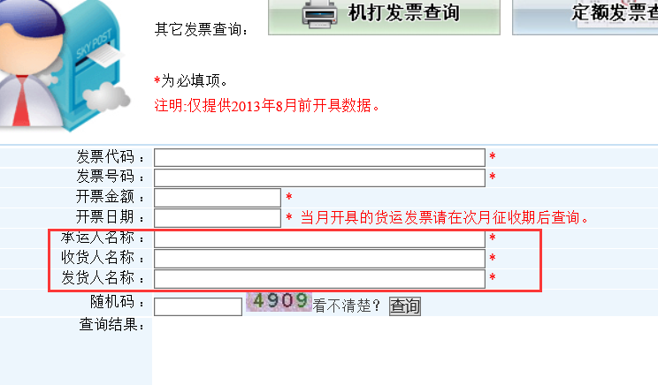

Taxtype：

|  |  |  |
| --- | --- | --- |
| 序号 | 各分税务网站 | 查询内容 |
| 1 | 四川地税 | 普通发票基本信息 sc_local |
| ~~有奖发票基本信息~~ sc_reward |
| 2 | 四川国税 | 通用信息查询； sc_national |
| 3 | 重庆国税 | 网络发票开具查询 cq_national |
| 发票流向查询 cq_flow |
| 冠名发票查询 cq_named |
| 增值税发票查询 cq_added |
| 4 | 重庆地税 | 机打发票查询 cq_printed |
| 货运发票查询 cq_transpot |
| 定额发票查询 cq_quota |
| 5 | 广东国税 | 发票查验 gd_national |
| 网络发票查验 gd_network |
| 发票流向查询 gd_flow |
| 6 | 上海国税 | 通用信息查询； shh_national |
| 7 | 云南国税 | 增值税发票流向查询  yn_added |
| 普通发票信息比对查询  yn_check |
| 8 | 北京国税 | 通用信息查询；bj_national |

## 1.5 查询信息提交反馈

http://ServerIP/taxquery/mapi/userservice/feedback

请求示例：可以将发票的输入信息与结果一起合并成字符串,作为info的内容；verify为用户对查询结果的确认状态（真或假）

{"phone":"156xxx","taxtype":"sc_local","fpdm":"3432579852"

,"fphm":"9876556","info":"发票的查询结果"

,"verify":"true"} 用户确认查询的结果状态有三种:true（发票结果真）,false（发票结果假）,unkonwn（未知）

返回示例：{"msg":"*succeed*","detail":"保存成功"}

{"msg":"*error*","detail":"保存失败"}

## 1.6 获取历史查询记录

http://ServerIP/taxquery/mapi/userservice/history

请求示例：

{"phone":"156xxx","begin":"2015-03-01","end":"2015-04-30","page":"1"}

返回示例：

{"msg":"*succeed*","total_page":"*10*","page_no":"*1*","detail":json数组}

{"msg":"error","detail":"没有记录"}

json数组

[

{"taxtype":"sc_national","fpdm":"45579852"

,"fphm":"18764356","info":"发票的具体信息",

"verify":"true","querydate":"2015-08-01"},

{"taxtype":"gd_national","fpdm":"983652623"

,"fphm":"7423982","info":"发票的具体信息",

"verify":"false","querydate":"2015-08-02"},

{"taxtype":"yn_national","fpdm":"104983264"

,"fphm":"5957299","info":"发票的具体信息",

"verify":"unkonwn","querydate":"2015-08-05"}

]

## 1.7 获取所有历史查询记录（admin/admin 才能获取）

http://ServerIP/taxquery/mapi/userservice/allhistory

请求示例：

{"phone":"admin","begin":"2015-03-01","end":"2015-04-30","page":"1"}

返回示例：

{"msg":"*succeed*","total_page":"*10*","page_no":"*1*","detail":json数组}

{"msg":"error","detail":"没有记录"}

json数组

[

{"phone":"1333xxx","taxtype":"sc_national","fpdm":"45579852"

,"fphm":"18764356","info":"发票的具体信息",

"verify":"true","querydate":"2015-08-01"},

{"phone":"1255xxc","taxtype":"gd_national","fpdm":"983652623"

,"fphm":"7423982","info":"发票的具体信息",

"verify":"false","querydate":"2015-08-02"},

{"phone":"135cccccc","taxtype":"yn_national","fpdm":"104983264"

,"fphm":"5957299","info":"发票的具体信息",

"verify":"unkonwn","querydate":"2015-08-05"}

]